**Lesson 01 Demo 01**

**Configuring Docker Daemon to Start on Boot**

**Objective:** To configure the Docker Daemon to start on boot and customize Docker's settings to control disk space for images and containers

**Tools required:** Docker

**Prerequisites:** None

Steps to be followed:

1. Configure Docker Daemon
2. Start and configure docker service using upstart command

**Step 1: Configure Docker Daemon**

1. Use the following command to update the package index:

**sudo apt update**

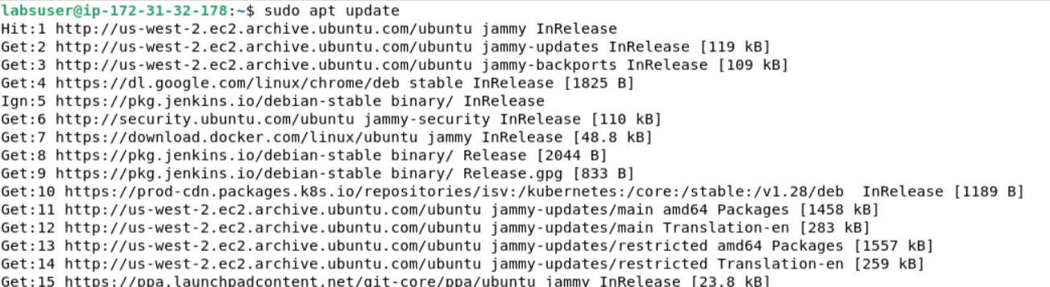

1. Use the following command to install the required packages to allow apt to use a repository over HTTPS:

**sudo apt install apt-transport-https ca-certificates curl software-properties-common**

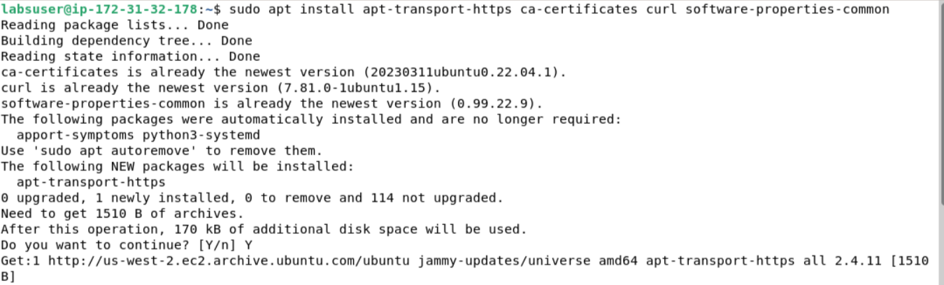

1. Use the following command to add Docker's official GPG key:

**curl -fsSL https://download.docker.com/linux/ubuntu/gpg | sudo apt-key add -**



1. Use the following command to add the Docker repository to your system's software sources:

**sudo add-apt-repository "deb [arch=amd64] https://download.docker.com/linux/ubuntu $(lsb_release -cs) stable"**

1. Use the following command to update the package database with the Docker packages from the newly added repo:

**sudo apt update**

1. Use the following command to install Docker:

**sudo apt install docker-ce**

1. Use the following command to start the Docker service:

**sudo systemctl start docker**

1. Use the following command to enable Docker to start on boot:

**sudo systemctl enable docker**



1. Use the following command to disable Docker Daemon on the boot:

**sudo systemctl disable docker**

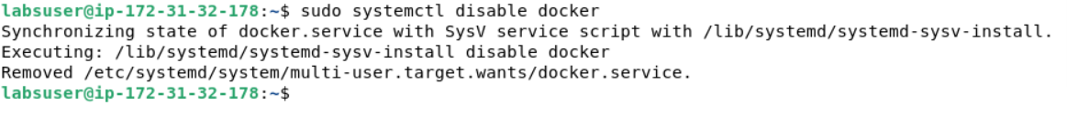

1. Use the following command to reload Docker Daemon:

**sudo systemctl daemon-reload**



**Step 2: Start and configure docker service using upstart command**

1. Use the following command to disable Docker start on the system boot:

**echo manual | sudo tee /etc/init/docker.override**



1. Use the following command to move to /etc/docker/ folder:

**cd /etc/docker/**

1. Use the following command to create the **daemon.json** file:

**sudo vi daemon.json**

1. Configure the **daemon.json** file by setting the appropriate flags to manage the disk space allocated for Docker images and containers

**{**

**"data-root": "/mnt/docker-data",**

**"storage-driver": "overlay2"**

**}**

|  |
| --- |
| **Note:** After writing the above code in the **daemon.json** file, press the ESC button and type**:wq** to save the file and exit the editor |

By following these steps, you have successfully configured the Docker Daemon to start on boot and customized Docker’s settings to manage disk space for images and containers.